**Box Plot:**

A box plot is a graphical representation of the distribution of a dataset. The box represents the interquartile range (IQR), with the median (Q2) marked within it. The whiskers extend to the minimum and maximum values, excluding outliers. Outliers are represented by individual points.

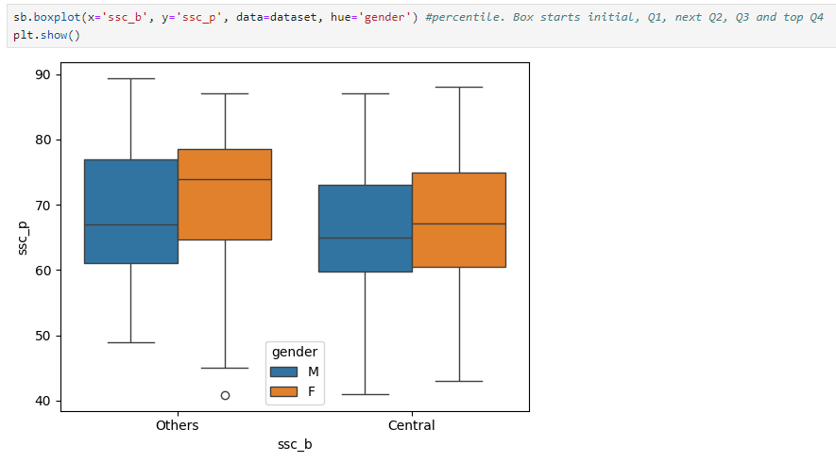

**Key Observations:**

1. **Board:**
   * **Others:** The overall distribution of ssc_p for students from the "Others" board is slightly lower than that for students from the "Central" board.
   * **Central:** Students from the "Central" board generally have higher secondary school percentages.
2. **Gender:**
   * **Others:** Within the "Others" board, there is a slight difference between male and female students. The median ssc_p for males is slightly higher than that for females.
   * **Central:** In the "Central" board, the distributions for male and female students are more similar.
3. **Outlier:**
   * Present in Others

**Summary of Quartiles:**

* **Others:**
  + **Male:** Q1 = 61, Q2 = 68, Q3 = 76, Q4 = 89
  + **Female:** Q1 = 65, Q2 = 70, Q3 = 78, Q4 = 88
* **Central:**
  + **Male:** Q1 = 65, Q2 = 72, Q3 = 79, Q4 = 90
  + **Female:** Q1 = 67, Q2 = 73, Q3 = 80, Q4 = 89